**OUTPUT**

Case 1: upperlimit = 10

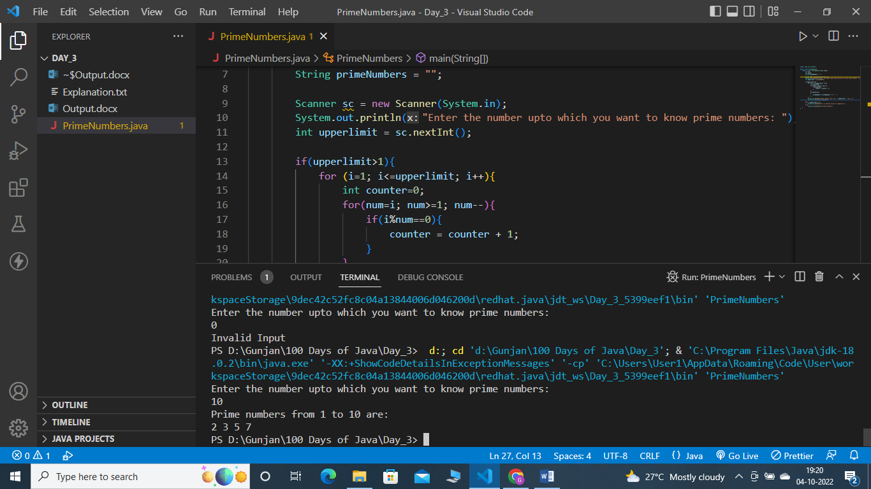

Case 2: upperlimit = -10

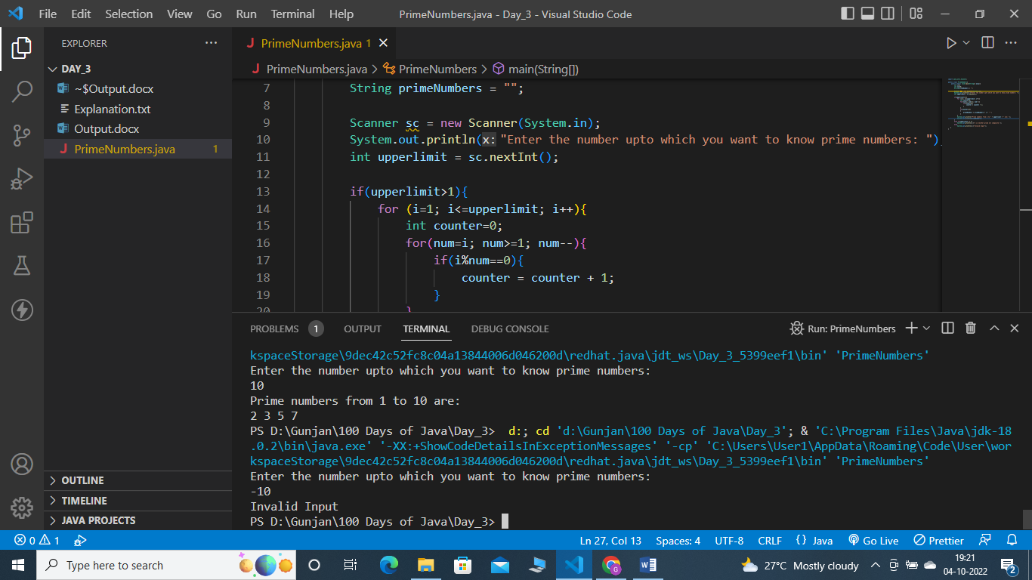

Case 3: upperlimit = 1

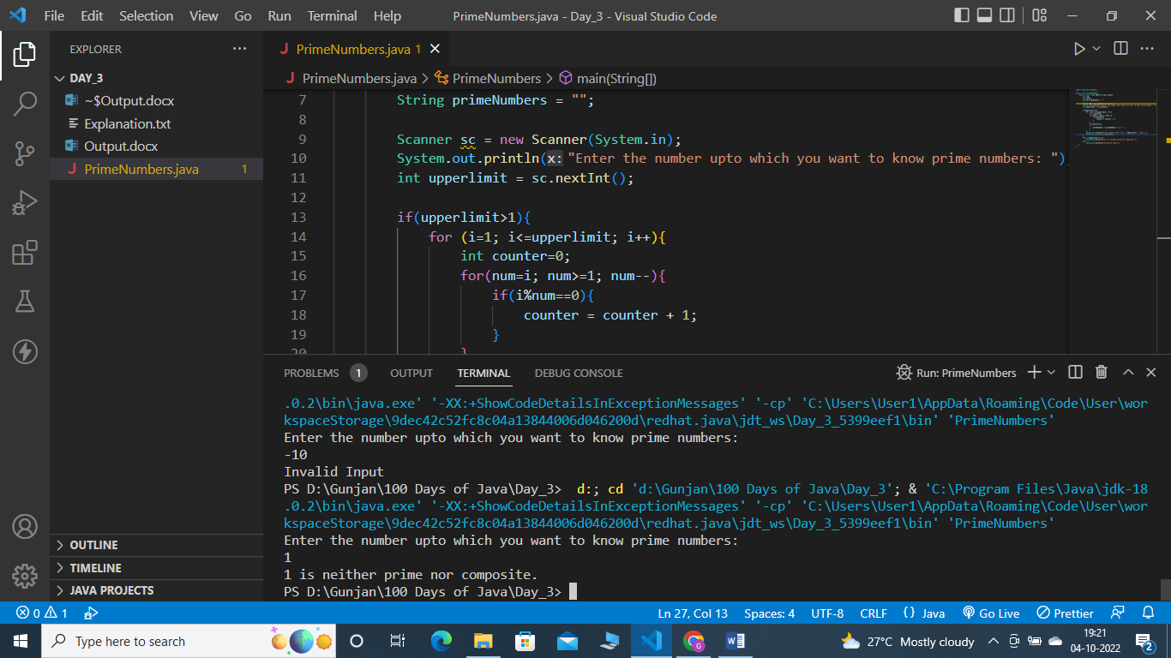

Case 4: upperlimit = 0

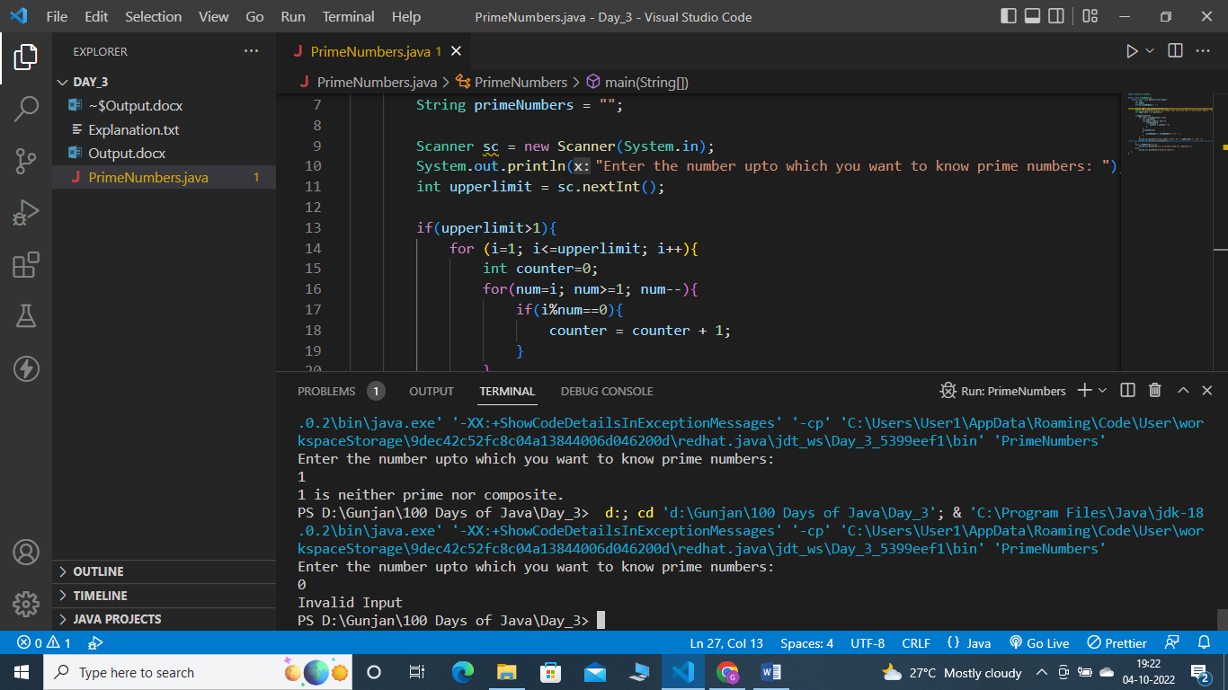

Case 5: upperlimit = A

